SH 121 Public Hearing Location Maps
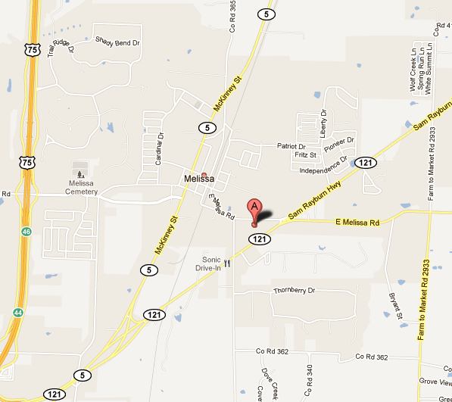
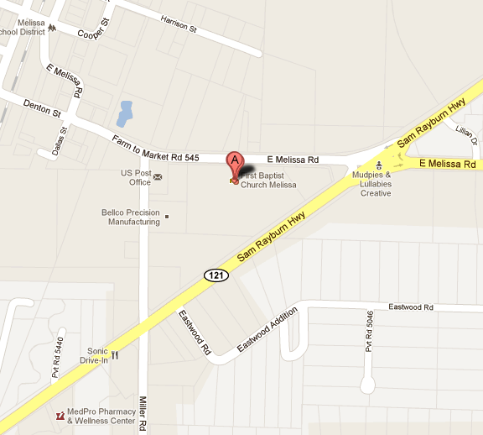
SH 121 Public Hearing Location Maps

Tuesday, November 1, 2011
6 pm – 8 pm

First Baptist Church Melissa
2101 Melissa Road East (FM 545)
Melissa, Texas 75454

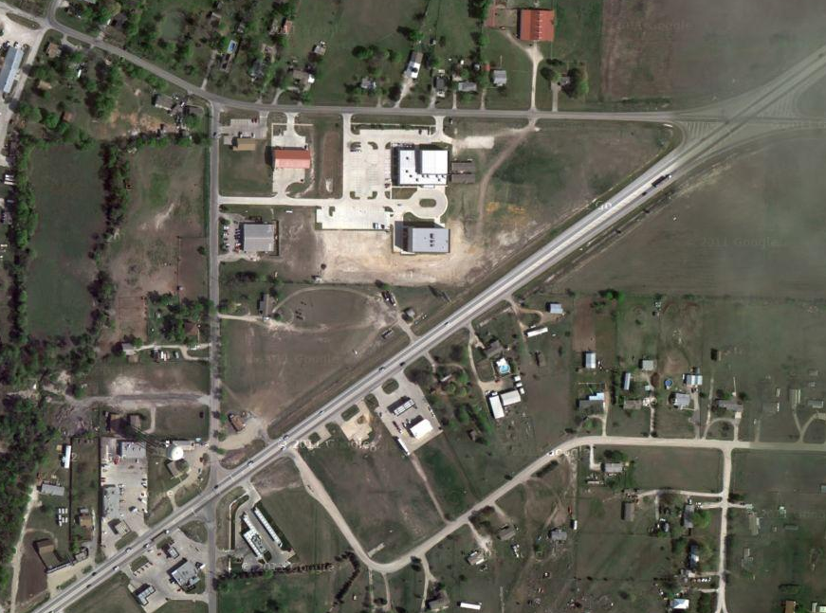
SH 121
Miller Road
FIRST BAPTIST CHURCH MELISSA

Melissa Road East (FM 545)
TO US 75

